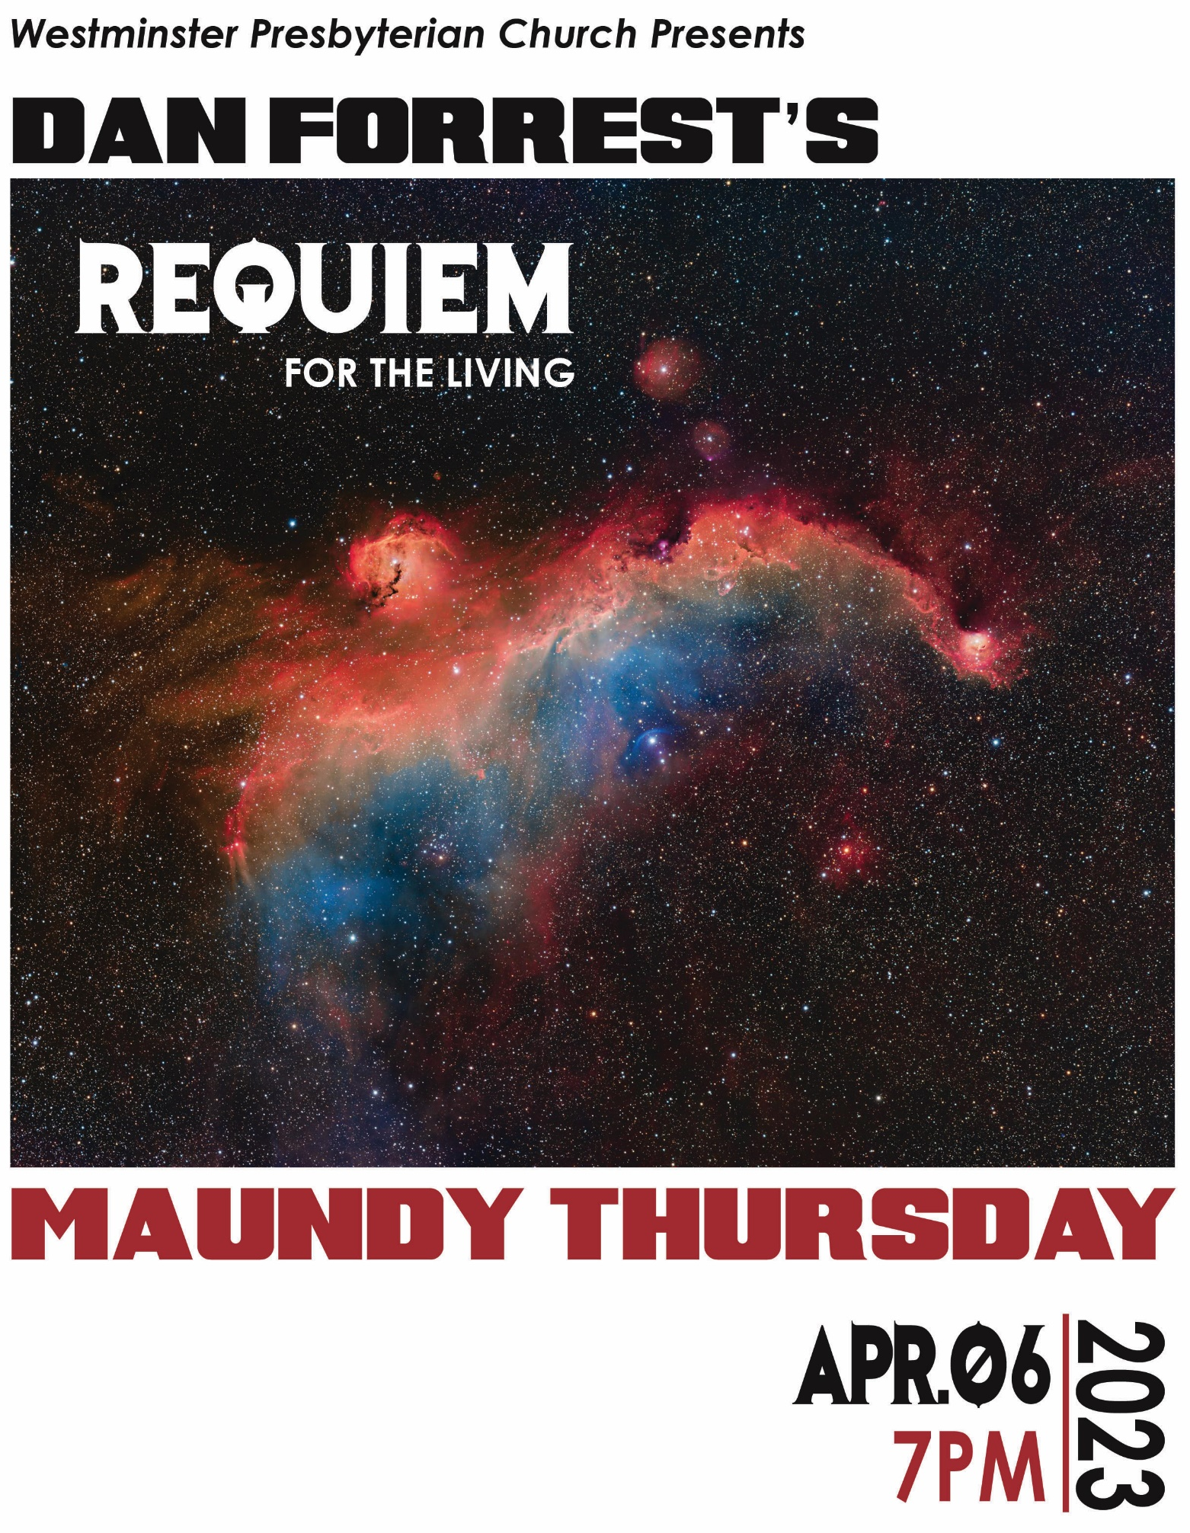

Maundy Thursday Service
April 6, 2023
7:00 p.m.

Welcome and Invocation Dr. Kristofer D. Holroyd
Prelude Elegy by Samuel Taylor-Coleridge
Stephen Price, organ
Call to Worship Mark 15:6-39 (ESV)
*Song of Praise O Sacred Head, Now Wounded (Hymn #247)
*Scripture Reading Isaiah 53:3-6 (ESV)
Requiem for the Living by Dan Forrest
The Lord’s Table

The Apostles’ Creed
All:
I believe in God the Father Almighty,
Maker of heaven and earth.
I believe in Jesus Christ, his only Son, our Lord,
who was conceived by the Holy Spirit,
and born of the virgin Mary.
He suffered under Pontius Pilate,
was crucified, died, and was buried;
he descended into hell.
The third day he rose again from the dead.
He ascended into heaven
and is seated at the right hand of God the Father Almighty.
From there he will come to judge the living and the dead.
I believe in the Holy Spirit,
the holy catholic church,
the communion of saints,
the forgiveness of sins,
the resurrection of the body,
and the life everlasting. Amen.
*Song of Response Christ, We Do All Adore Thee (#737)

*Benediction

1. Introit - Kyrie  Requiem aeternam dona eis, Domine,  et lux perpetua luceat eis.  Exaudi orationem meam,  ad te omnis caro veniet.  Kyrie eleison. Christe elesion. Kyrie eleison. |  | Rest eternal grant to them, O Lord,  and let perpetual light shine upon them.  Hear my prayer, for unto Thee all flesh shall come. Lord have mercy; Christ have mercy;  Lord have mercy.
2. Vanitas Vanitatum  Vanitas vanitatum, omnia vanitas!  Pie Jesu Domine, dona eis requiem.  Lacrimosa,  et locutus est, pereat dies in qua natus sum. |  | Vanity of vanities, all is vanity!  (from Ecclesiastes)  Merciful Lord Jesus, grant them rest.  Full of tears,  (from the Dies Irae)  He said, Let the day perish wherein I was born.  (From Job 3:2-3)
3. Agnus Dei  Agnus Dei, qui tollis peccata mundi,  miserere nobis, dona eis requiem.  Agnus Dei, qui tollis peccata mundi,  dona nobis pacem, miserere nobis,  dona eis requiem. |  | Lamb of God,  who takes away the sins of the world,  have mercy on us; grant them rest.  Lamb of God,  who takes away the sins of the world,  grant us peace; have mercy on us;  grant them rest.
4. Sanctus  Sanctus, Sanctus, Sanctus,  Dominus Deus Sabaoth.  Pleni sunt caeli et terra gloria tua.  Hosanna in excelsis! |  | Holy, Holy, Holy,  Lord God of Hosts.  Heaven and earth are full of Thy glory.  Hosanna in the highest!
5. Lux Aeterna  Lux aeterna, luceat eis, Domine:  Cum sanctis tuis in aeternum: quia pius es.  Et lux perpetua luceat eis. |  | May light eternal shine upon them, O Lord,  in the company of Thy saints forever:  for Thou art merciful.  Let perpetual light shine on them.
Come unto me,
all ye who labor and are heavy laden,
and I will give you rest.
 |  | (Matthew 11:28)
Requiem aeternam dona eis, Domine,  et lux perpetua luceat eis.  Dona nobis pacem. |  | Rest eternal grant to them, O Lord,  and let perpetual light shine on them.  Grant us peace.
Conductor’s Note:
While it is impossible to know the precise number, some musical historians have estimated that the text for the traditional Requiem Mass has been set to music at least 5,000 times. This is a surprisingly large number, especially when considering that even the most avid musicologist might only be familiar with a few of these (Brahms, Fauré, Mozart, Verdi, and Rutter come to mind). So, the question beckons, what’s so important about this text?
The text for the Requiem Mass is primarily associated with a theological idea that is incongruent with a Reformed, or even a Protestant, understanding of Scripture – namely, praying for the souls of the dead. However, the underlying theme of the Requiem text transcends these theological conflicts. This underlying theme is simply death itself.
Throughout all time, both Christians and non-Christians have grappled with the ugly reality of death. We all struggle to cope with the messy, bitter nature of physical death, as well as the emotional and spiritual angst that inevitably accompany. And even more than this, almost none of us has avoided the painful uncertainty of not knowing if a particular friend or family member died with a saving knowledge of Christ. These profound and heart-wrenching issues have always sat at the heart of the Requiem text.
Dan Forrest’s Requiem for the Living is certainly a notable musical accomplishment, full of complexity, beauty, sorrow, anger, and ultimately hope. But perhaps its primary distinctive can be found in the title itself. Unlike most of his predecessors in Requiem composition, Forrest’s understanding of Biblical truth is much more similar to that of a Reformed congregation, which explains why he emphasizes not so much rest for those who have already died, but rest for those who are still alive. Hence the title, Rest (or Requiem) for the Living.
The traditional text situates the Agnus Dei after the Sanctus. However, Forrest reverses the order, which he explains as follows:
The third movement is the Agnus Dei, out of its traditional order, because at that point in the narrative, I need to see the Lamb of God, who died to redeem mankind from all fallenness- this vanity and pain and sorrow and destruction.
It's only after recognizing the Lamb of God that we can then turn, in this narrative, to the Sanctus. It becomes a response to the Agnus Dei, instead of prelude to it as in the normal liturgical order. Interestingly, I see the phrase "heaven and earth are full of Thy glory" as not merely a worship moment, but actually a part of the Divine answer to the problem of pain. Looking to Job again, God's answer to the problem of pain is literally, "Look at my works of creation- see my transcendent power and majesty" and of course Job is then humbled by the realization… As you can see, then, this movement depicts the wonder of the heavens and earth as a Divine answer to the problem of pain. My setting of the Sanctus text is literally a depiction of God's wondrous glory…
Forrest believes that God has provided an answer to our heart’s deepest questions, as well as to our heart’s most profound feelings of pain, by providing a Redeemer in Christ, and by displaying His glory all around us in creation, itself.
Apparently much of the inspiration for the music for the fourth movement – Sanctus – came from images from the Hubble Space Telescope, which explains the cover for tonight’s program.* As the Psalmist notes in #19, “The heavens declare the glory of God!” As we humble ourselves before the awe-inspiring, sometimes even terrifying glory of our Creator God, the question of “Why” gives way to the glory of the reality of “Who.”
In the middle of Forrest’s Requiem, we have the Lamb of God, or “Agnus Dei,” who takes away our sin. This is why we come together around this time every year to focus upon Jesus and His cross. We remember the horrific reality of His rejection on our behalf, His grief, His stripes, His death. And we remember that it was in the brutality of His crucifixion and the devastation of His bearing the curse of the sins of the world that we found all our hope for glory and salvation.
We pray that God would be glorified in our worship, as we look once again to the only One who can give requiem, or rest, to both the living and the dead.
-Nate Shockey

*The image on the cover is courtesy of Gary Imm, a wonderful astrophotographer and personal friend from Onalaska, TX. Please enjoy more of his photography from his website, https://www.astrobin.com/users/GaryI/collections/
**Special thanks, as well, to my talented and tireless wife Katey for designing the flyer.

SANCTUARY CHOIR
Sopranos |  | Altos
Betty Campbell |  | Lois Garringer
Teresa Case |  | Kathy Kirklin
Susan Harris |  | Becky McDonald
Jonė Holroyd |  | Jane McDowell
Johanna McKee |  | Nicole Morris
Laura Morales |  | Fran Nelson
Priscilla Scott |  | Colton Shockey
Ainsley Vaughn |  | Alexa Stanley
 |  | Gen Watson
 |  | Vickie Williamson
Basses |  | Tenors
John Branies |  | Jay Goller
Steve Brown |  | Tom Schroeder
Jerry Case |  | Gabriel Shockey
Ken Haller |  | Kevin Smith
Tom Harris
Phil Goshert
Roger Nelson
Len Sterrett
Larry Williamson
INSTRUMENTALISTS AND SOLOISTS
Soprano |  | Tenor
Allison Moore |  | Kevin Smith
Boy Soprano
Judah Shockey
Violin |  | Cello
Matthew Spieker |  | Heather Scott
Flute |  | Harp
Mihoko Watanabe |  | Joanna King
Oboe |  | Horn
Katie Garringer Martins |  | Gene P. Berger
Percussion |  | Organ
Jonathan Smith |  | Stephen Price
Ben Taubert
Rehearsal Accompanist
Teresa Case

Easter Sunday Schedule
8:30 a.m. First Worship Service
10:00–10:45 a.m. Easter Breakfast in the Fellowship Hall
11:00 a.m. Second Worship Service
No Evening Service

Regular Sunday Schedule
8:30 a.m. First Worship Service
9:45–10:00 a.m. Coffee in the Fellowship Hall
10:00 – 10:45 a.m. Sunday School
11:00 a.m. Second Worship Service
6:30 p.m. Evening Service*
*Small groups meet on the 2nd and 5th Sunday evenings of the month and there is no evening service.

Contact Us
2801 W. Riverside Ave.
Muncie, IN 47304
Office (765) 288-3355
www.westminpca.com

WiFi password ~ WestminsterPCA67

CCLI license #229062; streaming license #20175655

